Cloning vectors for higher plants (Ti-Plasmid based vectors)
Ti-plasmids
Crown gall is a neoplastic disease of most dicotyledonous plants and is caused by the soil bacterium Agrobacterium tumefaciens. A large extra-chromosomal plasmid in these bacteria was found to be responsible for its tumor-inducing capacity and was, therefore, called Ti-plasmid.
Ti plasmids are large, often more than 200 kb long, catabolic plasmids . A Ti plasmid can be transferred by conjugation to most Agrobacterium and some Rhizobium species.
A major characteristic of a Ti plasmid is that it contains, the vir or virulence genes, which enable a copy of one or more segments (T-DNA) of the Ti plasmid be transferred into plant cells, where it can become integrated into the plant genome.
The genes encoded by the T-DNA are under eukaryotic control and can be expressed in a plant background. This can result in a plant cell proliferation (crown gall formation) and the synthesis and secretion of a specific metabolite, of no use for the plant. These metabolites, called opines, are condensation products of amino acids, such as arginine and lysine, and abundant plant metabolites such as pyruvic acid, ketoglutaric acid, succinate, and mannose.
Thus, crown gall disease is a naturally evolved genetic engineering process. Crown gall formation is the consequence of the transfer integration and expression of genes of T-DNA of A. tumefaciens in the infected plant.
Organization of Ti plasmid
The Ti plasmid has three important regions: -
- T-DNA region: This region has the genes for the biosynthesis of auxin (aux), cytokinin (cyt) and opine (ocs), and is flanked by left and right borders. } T-DNA borders- A set of 24 kb sequences present on either side (right & left) of T- DNA are also transferred to the plant cells. It is clearly established that the right border is more critical for T-DNA transfer.
- Virulence region: The genes responsible for the transfer of T-DNA into host plant are located outside T-DNA and the region is reffered to as vir or virulence region. At least nine vir-gene operons have been identified. These include vir A, vir G, vir B1, vir C1, vir D1, D2, vir D4 and vir E1, E2.

- Opine catabolism region: This region codes for proteins involved in the uptake and metabolisms of opines.
- Besides the above three there is ori region that responsible for origin of DNA replication which permit the Ti plasmid to be stably maintain in A. tumefaciens.
Structure of Ti plasmid
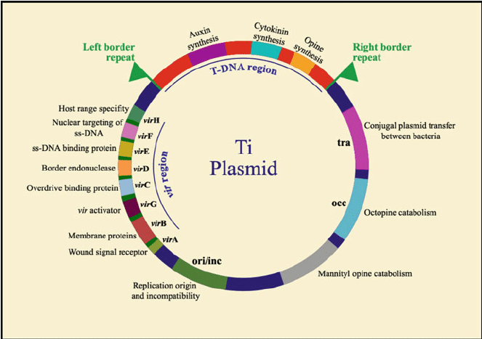
Constraints of Wild type Ti plasmid
- Very large
- Low copy number in Agrobacterium
- Difficult to isolate and manipulate in vitro
- Do not replicate in Escherichia coli, the favoured host for genetic manipulation.
- T-DNA regions from wild-type Ti-plasmids are generally large and do not contain unique restriction endonuclease sites suitable for cloning a gene of interest.
Features of efficient vector for plant transformation
- A selectable marker gene that confers resistance to transformed plant cells. As these marker genes are prokaryotic origin, it is necessary to put them under the eukaryotic control (plant) of post transcriptional regulation signals, including promoter and a termination- poly adenylation sequence, to ensure that it is efficiently expressed in transformed plant cells.
- An origin of replication that allows the plasmid to replicate in E.coli.
- The right border sequence of the T-DNA which is necessary for T-DNA integration into plant cell DNA.
- A polylinker (MCS) to facilitate the insertion of cloned gene into the region between T-DNA border sequences.
Co- integrate vectors
They are the first types of modified and engineered Ti plasmids devised for Agrobacterium -mediated transformation, but are not widely used today.
Co-integrate vectors are the deletion derivatives of Ti-plasmids. The DNA to be introduced into the plant transformation vector is sub cloned in a conventional Escherichia coli plasmid vector for easy manipulation, producing a so-called intermediate vector. These vectors are incapable of replication in A. tumefaciens and also lack conjugation functions. Transfer is achieved using a ‘triparental mating’ in which three bacterial strains are mixed together. Three vectors are necessary in this system:
A. Disarmed Agrobacterium Ti plasmids
In these Ti plasmids, the oncogenes located in the T-DNA region have been replaced by exogenous DNA.
Examples of these vectors include:
- SEV series: the right border of the T-DNA together with the phytohormone genes coding for cytokinin and auxin are removed and replaced by a bacterial kanamycin resistance gene while the left border and a small part of the left segment (TL) of the original T-DNA (referred to as Left Inside Homology (LIH)) are left intact.
- pGV series: the phytohormone genes are excised and substituted by part of pBR322 vector sequence. The left and right border sequences as well as the nopaline synthase gene of the Ti plasmid are conserved.
B. Intermediate vectors
- Small pBR322-based plasmids (E. coli vectors) containing a T-DNA region.
- Used to overcome the problems derived from the large size of disarmed Ti plasmids and their lack of unique restriction sites.
- Intermediate vectors are replicated in E. coli and are transferred into Agrobacterium by conjugation. They cannot replicate in A. tumefaciens and therefore, carry DNA segments homologous to the disarmed T-DNA to permit recombination to form a co-integrated T-DNA structure.
C. Helper vectors
These are small plasmids maintained in E. coli that contain transfer (tra) and mobilization (mob) genes, which allow the transfer of the conjugation-deficient intermediate vectors into Agrobacterium.
Conjugation between the two E. coli strains transfers the helper plasmid to the carrier of the intermediate vector, which in turn is mobilized and transferred to the recipient Agrobacterium. Homologous recombination between the T-DNA sequences of the Ti plasmid and intermediate vector forms a large co- integrate plasmid resulting in the transfer of recombinant T-DNA to the plant genome.
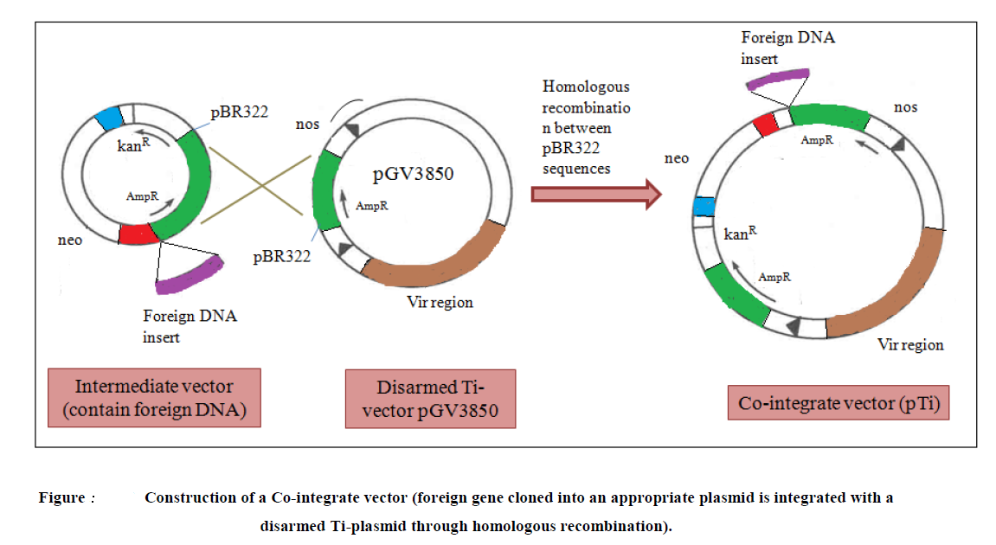
A resulting co-integrated plasmid assembled by in vitro manipulation normally contains:
- vir genes,
- left and right T-DNA borders,
- An exogenous DNA sequence between the two T-DNA borders,
- plant and bacterial (E. coli and A. tumifaciens) selectable markers,
- E. coli functional origin of replication that doesn’t operate in Agrobacterium
Disadvantages:
- Long region of homologies required between the Ti plasmid and the E. coli plasmids (pBR322 based intermediate vectors) making them difficult to engineer and use
- Relatively inefficient gene transfer compared to the binary vectors.
Binary vector strategy: two vector strategy
- Systems in which T-DNA and vir genes are located on separate replicons were eventually termed T-DNA binary systems
- Consists of a pair of autonomously replicating plasmid vectors
- Based on the knowledge that vir region need not be in the same plasmid along with T-DNA for transfer
Binary vector/shuttle vector:
–disarmed Ti-plasmid with gene of interest between T-DNA borders + ori for both E. coli and Agrobacterium also called as mini-Ti or micro Ti plasmid.
Helper Ti-plasmid:
–with virulence region that mediates transfer of T-DNA in micro Ti-plasmid to the plant
–Constructed by removing the T-DNA

Two different approaches have been mediated:
- Binary vector with two origin of replication: one for E.coli and the other for A. tumifaciens
- Binary vector with single broad host range origin of replication
In either case no vir genes are present on binary cloning vector. The vir genes present in a disarmed Ti plasmid from which the T-DNA has been removed synthesize vir proteins that eventually mobilize the T-DNA region of the binary cloning plasmid vector into the target plant cells.
Advantages of binary vectors
- Binary vectors do not require in-vivo recombination for preparation of vector as in co-integrate vectors.
- Binary vectors are more efficient and easier to obtain.
- In binary system the binary plasmids exist as separate replicons and thus their copy number remains flexible.
- The size of the binary vectors is relatively small and thus easier to manipulate.

Examples of Binary vector system
- pBIN19- one of the first binary vectors developed in 1980s and was widely used.
- pGreen- A newly developed vector with advanced features than pBIN19.
Both the vectors contain Lac Z gene for blue-white screening of recombinants. The reduction of size of pGreen is due to the presence of pSa origin of replication. An essential replicase gene is housed on a second plasmid, called pSoup which functions in trans. All conjugation functions have also been removed, so this plasmid can only be introduced into Agrobacterium.

